

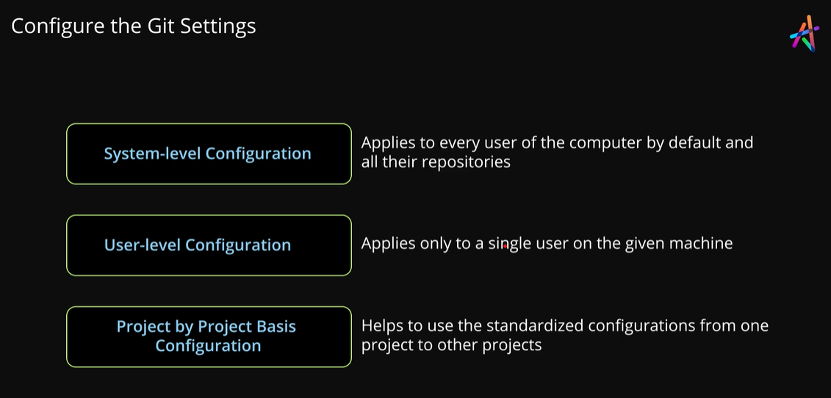

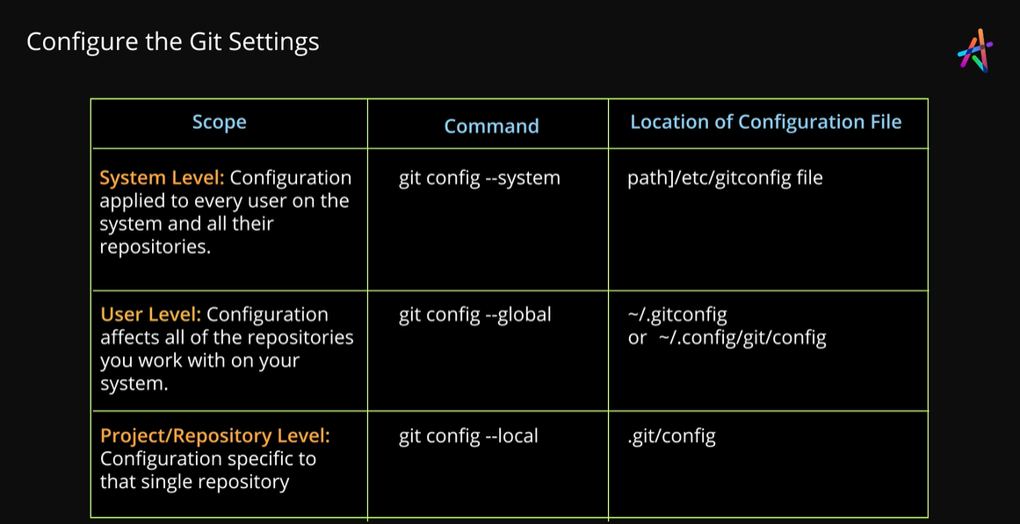

* Created a folder “Facebook”



* Opened folder with vs code
* Used command git config --global user.name
* Used command git config --global user.email
* Configure git for facebook folder (To set identity by username and email address when we use git to make changes to our projects files git uses this information to identify who made these changes.)



* Used command git config --global core.editor “code --wait”



* Git is going to pop up and open an editor for us to be able to type some text you can configure the default text editor that git can use for you to type in a message. if not configured git uses your systems default editor. So we could type git config --global core.editor “code --wait”.
* ( we could have Notepad.exe for example if your on windows or if you like to use wim or eemax you could set that option. I’m going to be using VS code text editor. its the most popular cross-platform text editor. So I’m gonna type “code --wait” ).

.